Top of Form

Bottom of Form


Business Requirement Documentation for Transfer & Relocation (“Look and See” Process) Development

Version and Approval

Version History
Version # | Date |  | Revised By | Reason for change
1.0 | 14-12-2022 |  | Bhavin Patel | Initial

This document has been approved as the official Business Requirements Document for Transfer & Relocation “Look and See” Process, and accurately reflects the current understanding of business requirements. Following approval of this document, requirement changes will be governed by the project’s change management process, including impact analysis, appropriate reviews and approvals.

Project Details

Project Name | Transfer & Relocation Project (Part 2: Look and See Process)
Project Type | Web Based
Division | HR
Project Manager/Dept

Project Overview

AUMENTO’s understanding is based on the meetings and information provided to us by HMSI. The company has strong and focused Plans to automize the transfer and relocation process using web-based portal that acts as an interface for all communications between HR and Associates, to save resources and eliminate human errors by automizing system. Where a strong, trusted, secured and scalable IT solution is required.

Having an Integrated Transfer and Relocation Web Portal Solution for HR, Users & Associates.
- To be Transfer initialization process
- Look and See process.
- Look and See settlement.
- Relocation process.
- Relocation settlement process.

Process Flow – Look and See
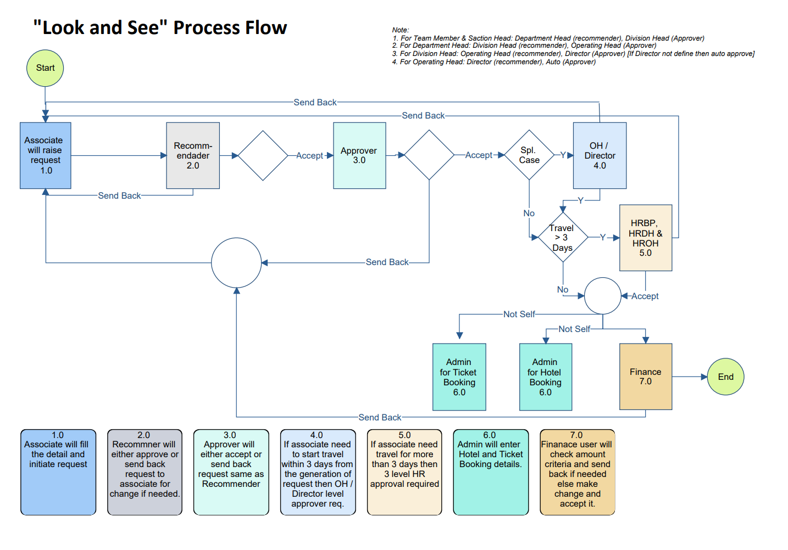

Process Flow – Look and See Settlement
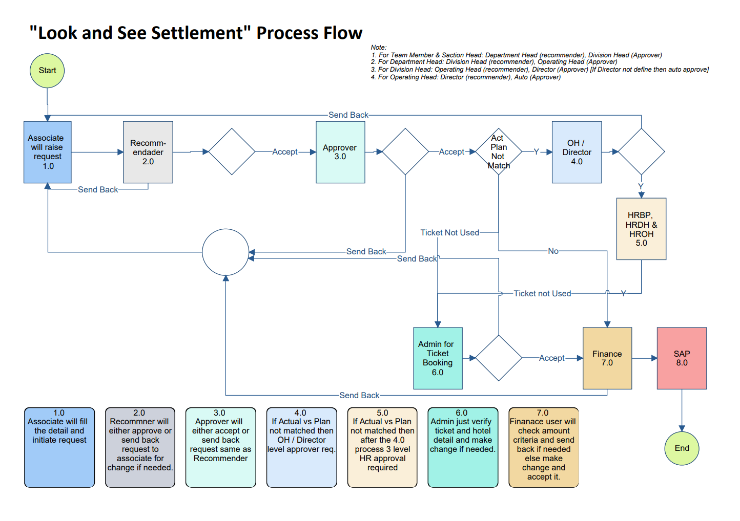

LOOK AND SEE INITIALIZATION

Associate
- Associate will fill following details for travelling and accommodation as given below.
  - Travel Date
  - Travel Time
  - From City
  - To City
  - Mode of Travel
  - Ticketing By (Self / Admin)
  - Flight / Train Name

  - City
  - Hotel Check In Date & Time
  - Hotel Check Out Date & Time
  - Booking By (Self / Admin)

  - Family Member Name
  - Relation
  - DOB
  - Gender
- After the fill all the above relevant details Associate submit record to Recommender.

Recommendation
- Recommender will study the details which filled by Associate and if found OK then Accept it else send back to Associate with the own remarks.

Approval
- Approver will also either Accept or Re-Send the request. If Accept then request move to next stage else request return back to Associate for further correction.
- If Associate want to travel after 3 days of request and Associate will return within 3 days then this request consider as Normal request. In Normal request Next stage after Approval is Finance.

Special Case Approval
- If Associate wants to travel within 3 days of request then its required Special Approval of Operating Head. If associate themselves is Operating Head then Special Approval required of Director only.

HRBP – HRDH - HROH
- If Associate want to travel for more than 3 days then whole 3 level HR approval is required. In the sequence of 1st HRBP, 2nd HRDH and 3rd HROH.

Admin - Ticket
- If Ticket Booking is required (Not by Associate) then after the all Approval, request move to Admin-Ticket. Admin will book ticket and fill the related details i.e. PNR No., Amount and attach a ticket.

Admin - Hotel
- If Hotel Booking is required (Not by Associate) then after the all Approval, request move to Admin-Hotel. Admin will book Hotel and fill the related details i.e. Hotel Name, Amount and attach a receipt.

Finance
- Finance user will confirm the Amount and filled details and either accept it or Send Back to Associate with remarks.

LOOK AND SEE SETTLEMENT

Associate
- Associate will update actual invoice details i.e. Ticket PNR No., Amount, Hotel Name, GST No. etc. after return from tour
- After the fill all the above relevant details Associate submit record to Recommender.

Recommendation
- Recommender will study the details which filled by Associate and if found OK then Accept it else send back to Associate with the own remarks.

Approval
- Approver will also either Accept or Re-Send the request. If Accept then request move to next stage else request return back to Associate for further correction.

Special Case Approval (Plan v/s Actual not matched)
- If Actual days not matched with planned days then Special Level approval required of Operating Head (in case of Operating Head Director will Approve), HRBP, HRDH and HROH one by one.
- If anyone send back the request then request return back to Associate else after all level Approval request move to next level.

Admin - Ticket
- If Ticket Not used then Admin level approval is required.

Finance
- After the all above approval record move to Finance. Finance user will confirm the Amount and filled details and either accept it or Send Back to Associate with remarks.

Common Notes:
- Each Associate has one Recommender, one Approval, one HRBP, one HRDH and one HROH. Admin and Finance will be Role base.

MIS Reports

- Discussion is pending.

Approval Matrix

Sr. No. | Name | Recommender | Approver
1 | Team Member | Department Head | Division Head
2 | Section Head | Department Head | Division Head
3 | Department Head | Division Head | Operating Head
4 | Division Head | Operating Head | Director
5 | Operating Head | Director | Auto

Screen Design

- Refer Annexure-B for Look and See Initialization.
- Refer Annexure-C for Look and See Settlement.

For: Aumento Technologies & Consulting Services Pvt Ltd
Bhavin Patel
Lokesh Shah
Kavan Shah

